Positron G.HN Programming

(QF Tech Assist)

Table of Contents

1.0 Overview 3
2.0 Effective Date 3
3.0 Related Documents 3
4.0 Overview 3
5.0 Login 4
6.0 View Subscriber Service 5
7.0 Create Subscriber Service 5
8.0 Edit Subscriber Service 7
9.0 View VLANS 9
10.0 Troubleshooting 10
10.1 DHCP 10
10.2 Bridge Modem Details 10
10.3 Modem Details 11
11.0 Delete Subscriber Service 13
12.0 Document Management 13

Overview

Target Audience | QF Programming
Impact/Benefit | The following M&P provides steps for programming service in a Positron G.hn (GAM) device.
Reason for Change | Updated title to remove COR-TSC.

Effective Date

Effective Date | Expiration Date
05/18/22 | Until Further Notice

Related Documents

Document Name
G.hn HSI Installation and Repair
Quantum Fiber C5500XK SmartNID Integrated ONT Installation Guidelines
Positron -Create Programming.webm
Positron - View Programming.webm
Visit the library to view all documents: https://centurylink.sharepoint.com/sites/NAOLibrary

Overview
Positron G.hn Fiber Extension will improve MDU/MTU broadband service for existing underserved assets by enhancing performance and speed offering, where placing fiber to the unit is not an option due to wiring restrictions or cost.
- Available in Quantum Fiber only
- Supports HSI speeds up to 940M
- Programmed through G.hn Access Multiplexer (GAM Device)
- Requires a G1001-M Bridge modem and an approved Quantum Fiber modem (gateway)
- GAM Devices available in 12 or 24 port design (image below)

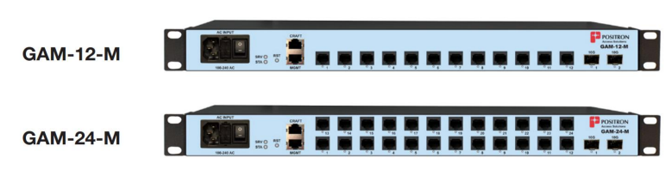

Login

Step | Action
Type the IP address for customer’s Device (CLLI) into a web browser and press enter.
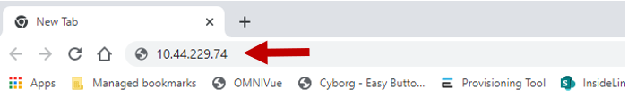
*Chrome is the preferred browser!
Sign in box will open. Enter CUID in the Username field, and Password, and select Sign in.
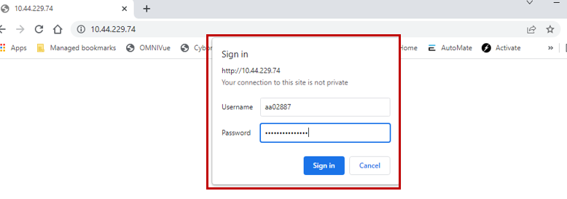
Successful logins should display the Positron Access Multiplexer screen like the one below.
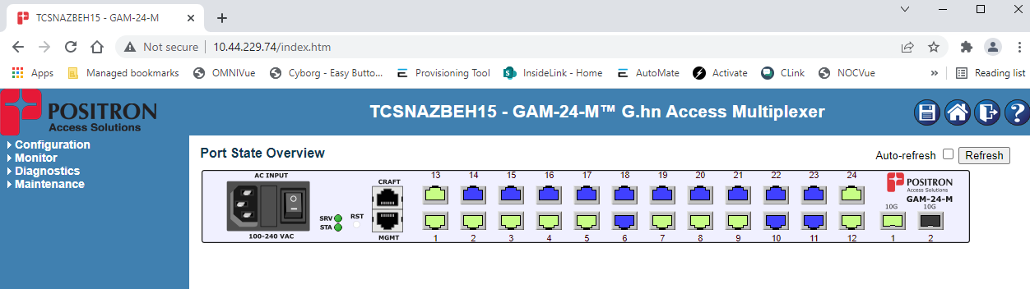
Note: The example above shows a 24-port device.

View Subscriber Service

Step | Action
Select Configuration > G.hn > Subscribers (left side menu).
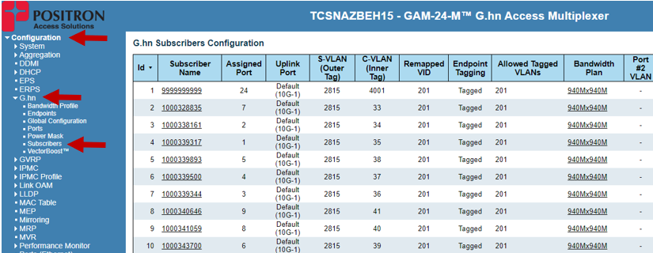
All provisioning subscribers will be listed with TN, Port, VPI/VCI and Provisioned Speed visible.
Endpoint will be populated if the G.hn modem is physically connected.
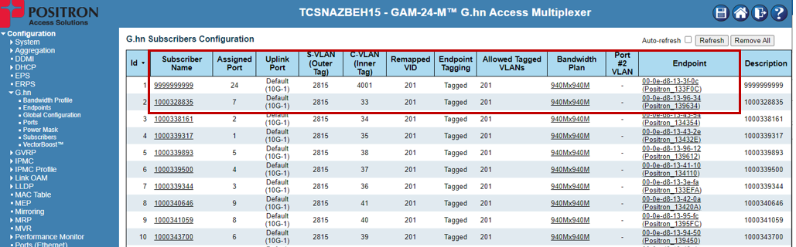
*Subscribers are listed in the order they are created, not by their assigned Port #!
Note: If the customer is not provisioned, see Create Subscriber Service for steps to create.

Create Subscriber Service

Step | Action
Select Configuration > G.hn > Subscribers (left side menu).

Select Add New Subscriber (bottom of the subscriber list).
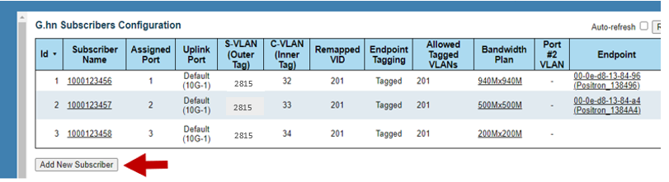
Populate the following fields:
- Subscriber Name = Customer DTN
- Assigned Port = Select Customer Port
- Double Tagging = Check to Enable
- S-VLAN (Outer Tag) = VPI
- C-VLAN (Inner Tag) = VCI
- Remapped VID = 201
- Endpoint Tagging = Check to Enable
- Allowed Tagged VLAN = 201
- Bandwidth Plan = Select Customer Speed
- Description = Customer DTN
Select Save.
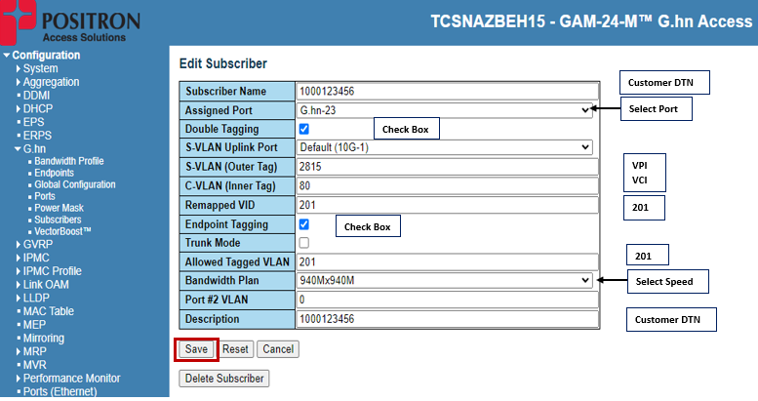
Successfully provisioned service will show in the G.hn Subscribers Configuration list.
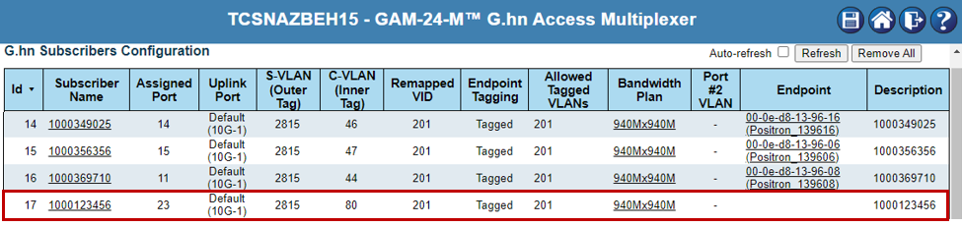
Note: The MAC address of the Endpoint (G.hn Modem) will populate once the Technician connects equipment during installation.

Edit Subscriber Service
To edit service, the account can be deleted and rebuilt or edit an existing account using the steps below.

Step | Action
Select Configuration > G.hn > Subscribers (left side menu).

Locate the Customer DTN in the list of Subscriber Names and select it to open.
(Example below, with Test DTN 9999999999).
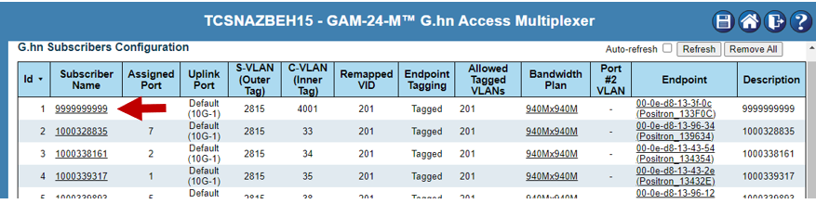
Edit Subscriber should open and allow updates to any of the fields displayed, including:
- Customer DTN
- Assigned Port
- S-VLAN (VPI)
- C-VLAN (VCI)
- Provisioned Speed
- 201 Tagging (Remapped VID & Tagged VLAN)

Make any necessary changes and select Save.
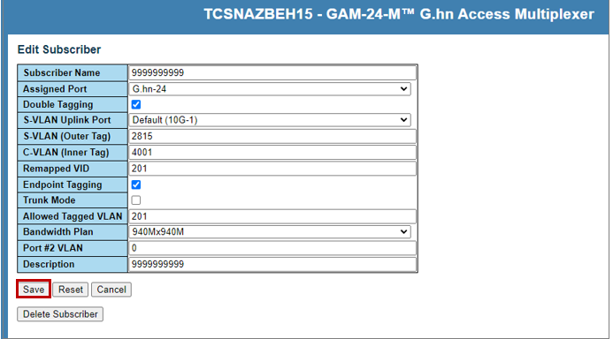
TIP!! The Subscriber can be deleted using the same steps!

View VLANS
Step | Action
Select Configuration > G.hn > Subscribers (left side menu).
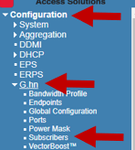
All provisioned C-VLANs (VCIs) will be listed in the C-VLAN column.
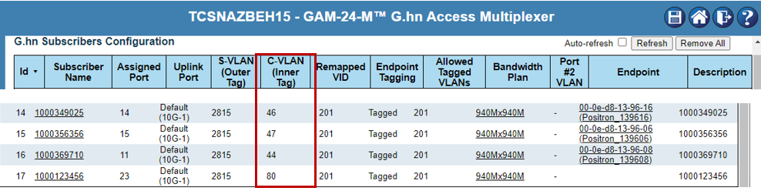

Troubleshooting
When there are issues of no PING or incorrect speeds, always verify the port is provisioned correctly and an IMPROV account is setup for the DTN using the correct VLANs and speed. See View or Create for steps on reviewing or creating subscriber accounts. If provisioning is correct, and the steps below do not resolve the issue, ask the Technician to try a new Bridge modem & gateway, or move to a new port.

DHCP
Step | Action
Verify a subscriber is pulling an IP Address using the DHCP Snopping Table located under Monitor:
Monitor > DHCP > Snooping Table
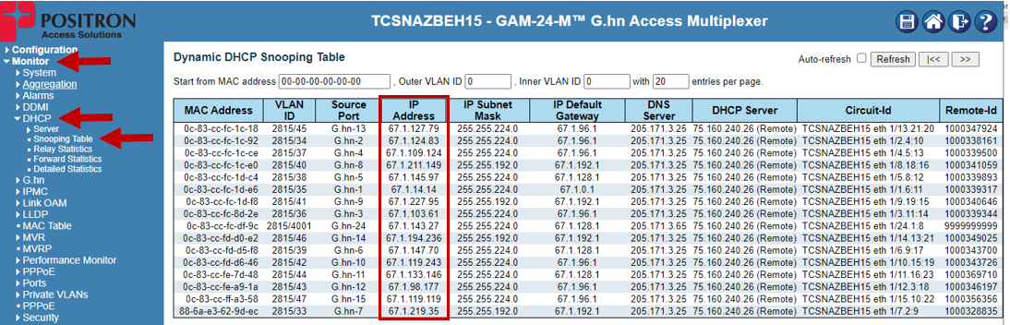

Bridge Modem Details
Positron G.hn service will be installed using a G1001-M bridge that will terminate signal from the GAM (G.hn Access Multiplexer device) and convert it to ethernet for GPON approved gateways. This means simply, a G1001-M bridge must be installed between the port and the modem.

Step | Action
The G1001-M (G.hn Bridge Modem) should be visible in the Endpoint column of subscriber’s configuration table or G.hn overview:
Configuration > G.hn > Subscribers
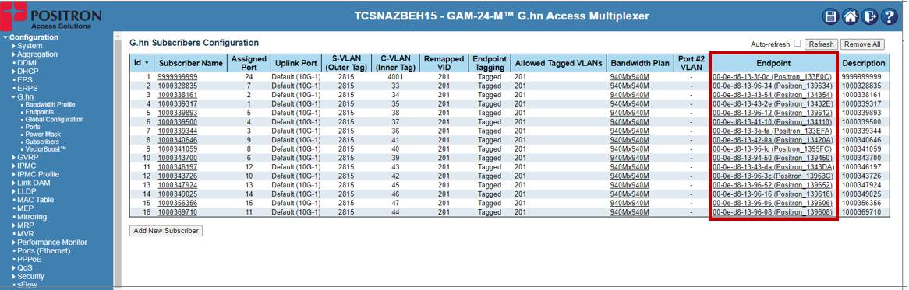

Monitor > G.hn > Overview
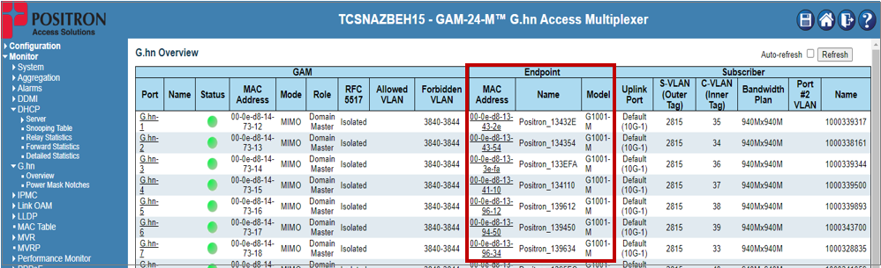

Modem Details
An approved Quantum Fiber modem (Residential Gateway) will be placed on the customer side of the G1001-M Bridge (Endpoint). Validate the modem is attempting to PING using DHCP detailed Statistics:

Step | Action
Select Monitor > DHCP > Detailed Statistics (left side menu).
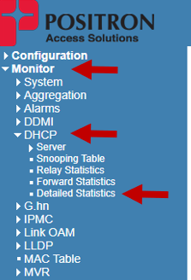
The DHCP process is Rx Discover à Tx Offer à Rx Request à Tx Acknowledgement.

*Acknowledgement (Tx ACK) indicates the Residential Gateway has received an IP:
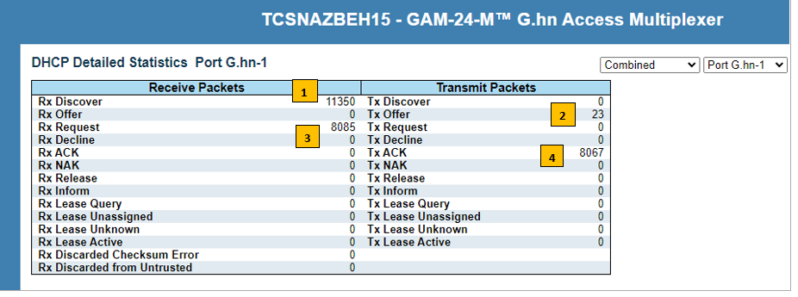
Note: Change G.hn port view using the drown down in the top right corner.

Delete Subscriber Service

Step | Action
Select Configuration > G.hn > Subscribers (left side menu).

Locate the Customer DTN in the list of Subscriber Names and select it to open.
(Example below, with Test DTN 9999999999).

Select Delete Subscriber.
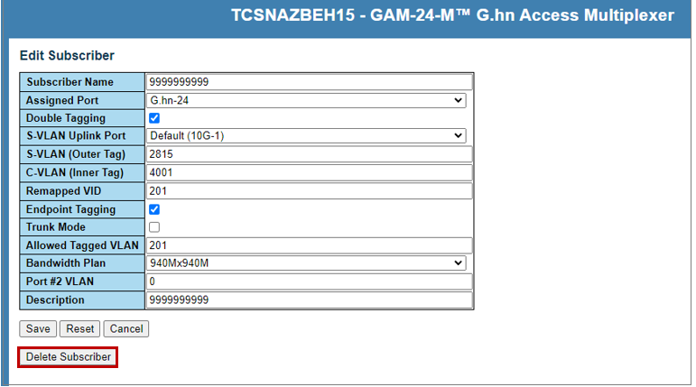

Document Management

Document Management
AUTHORS
Author | SME |  | Name |  |  |  | Telephone Number | E-mail Address
X |  |  | Yolanda Garner |  |  |  | 206-580-2629 | Yolanda.Garner@lumen.com
REVISIONS
Date |  | Issue |  | Revised By |  | Comments
05/18/22 |  | 1 |  |  |  | Initial Version
05/25/22 |  | 2 |  | Angela Cox |  | Updated for Certification Review
12/04/24 |  | 3 |  | Yolanda Garner |  | The Related Documents section has been updated to include two new videos on viewing and creating Positron programming.  Update Document Approval from Paula Carazzai to Jackie Stecher and document owner from Angela Cox to Yolanda Garner.
11/20/25 |  | 4 |  | Joela Flaxa |  | Updated title to remove COR-TSC.
APPROVAL
Name |  |  |  |  | Title |  |  |  | Date Approved
Jackie Stecher |  |  |  |  | Manager – Mass Markets Ops Excellence |  |  |  | 05/18/2022

